 | Question ID | Question Description | Picture | Answer
 | 1 | This sign indicates | 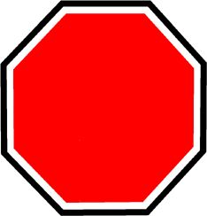 | Stop
 | 2 | This sign indicates | 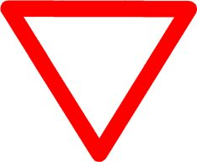 | Give way
 | 3 | This sign indicates | 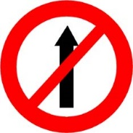 | No entry
 | 4 | This sign indicates | 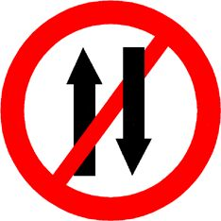 | One way
 | 5 | This sign indicates | 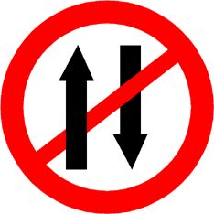 | One way
7 | 7 | This sign indicates | 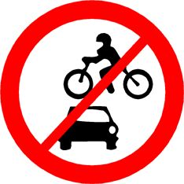 | All motor vehicles prohibited
 | 8 | This sign indicates | 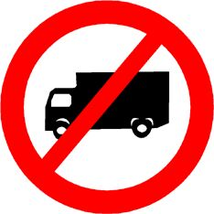 | Truck prohibited
 | 11 | This sign indicates | 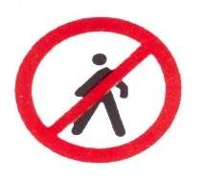 | Pedestrians prohibited
 | 12 | This sign indicates | 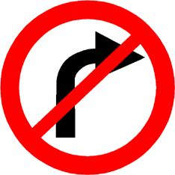 | Right turn prohibited
 | 13 | This sign indicates | 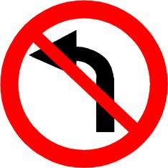 | Left turn prohibited
 | 14 | This sign indicates | 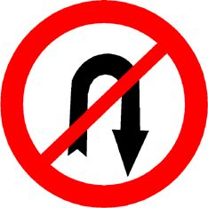 | U turn prohibited
 | 15 | This sign indicates | 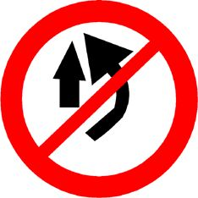 | Overtaking prohibited
 | 16 | This sign indicates | 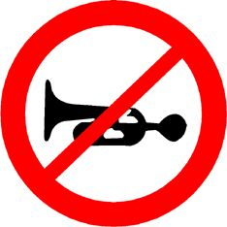 | Horn prohibited
 | 17 | This sign indicates | 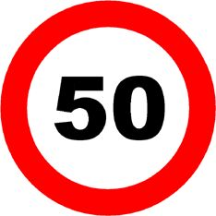 | Speed limit
 | 18 | This sign indicates | 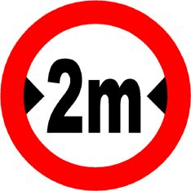 | Width limit
 | 19 | This sign indicates | 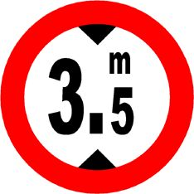 | Height limit
 | 20 | This sign indicates | 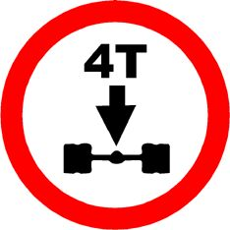 | Axle load limit
 | 21 | This sign indicates | 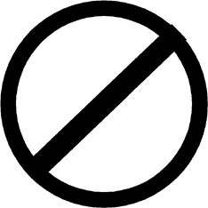 | Restriction ends
 | 23 | This sign indicates | 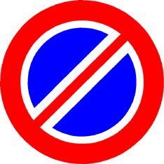 | No parking
 | 24 | This sign indicates | 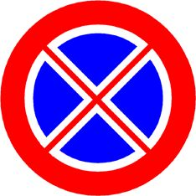 | No stopping
 | 25 | This sign indicates | 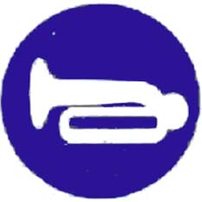 | Compulsory sound horn
 | 27 | This sign indicates | 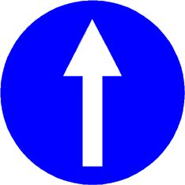 | Compulsory ahead only
 | 28 | This sign indicates | 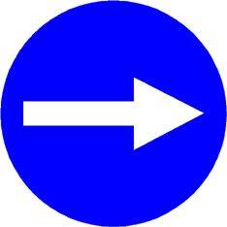 | Compulsory turn right
 | 29 | This sign indicates | 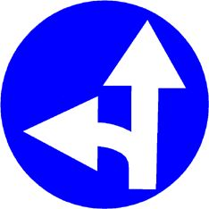 | Compulsory ahead or turn left
 | 35 | This sign indicates | 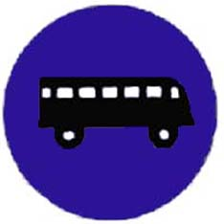 | Compulsory bus stop
 | 36 | This sign indicates | 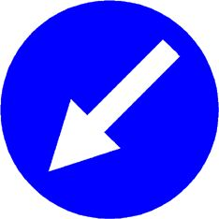 | Compulsory keep left
 | 38 | This sign indicates | 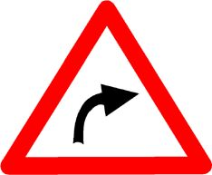 | Right hand curve
 | 39 | This sign indicates | 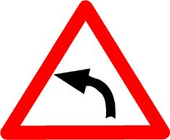 | Left hand curve
 | 40 | This sign indicates | 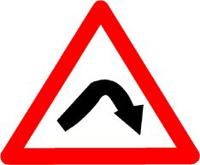 | Right hair pin bend
 | 41 | This sign indicates | 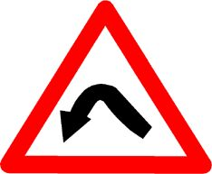 | Left hair pin bend
 | 42 | This sign indicates | 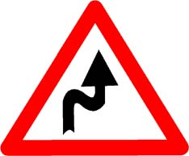 | Right reverse bend
 | 43 | This sign indicates | 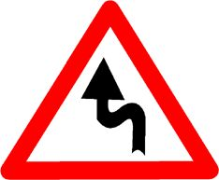 | Left reverse bend
 | 46 | This sign indicates | 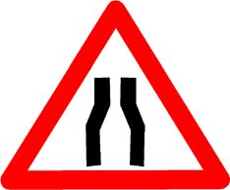 | Narrow road ahead
 | 47 | This sign indicates | 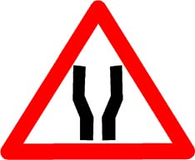 | Road widens ahead
 | 48 | This sign indicates | 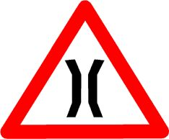 | Narrow bridge
 | 49 | This sign indicates | 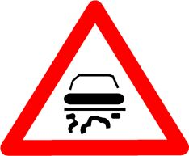 | Slippery road
 | 50 | This sign indicates | 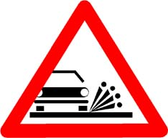 | Loose gravel
 | 52 | This sign indicates | 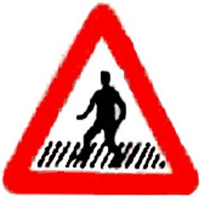 | Pedestrian crossing
 | 53 | This sign indicates | 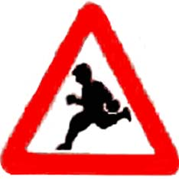 | School ahead
 | 56 | This sign indicates | 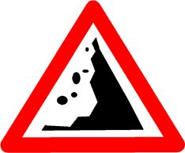 | Falling rocks
 | 57 | This sign indicates | 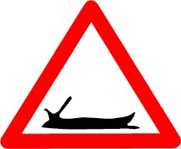 | Ferry
 | 59 | This sign indicates | 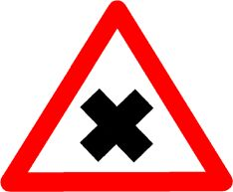 | Cross road
 | 60 | This sign indicates | 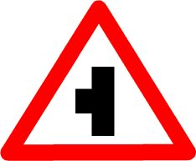 | Side road left
 | 61 | This sign indicates | 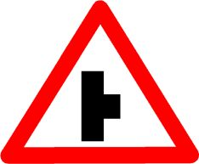 | Side road right
 | 62 | This sign indicates | 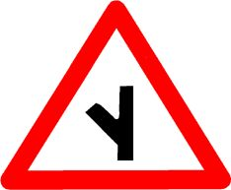 | Y- intersection
 | 63 | This sign indicates | 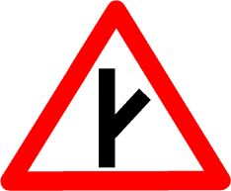 | Y- intersection
 | 64 | This sign indicates | 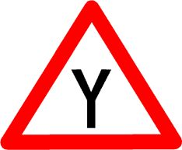 | Y- intersection
 | 65 | This sign indicates | 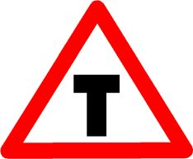 | T- intersection
 | 66 | This sign indicates | 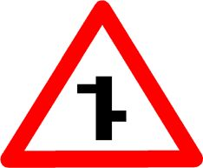 | Staggered intersection
 | 67 | This sign indicates | 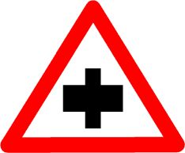 | Major road ahead
 | 68 | This sign indicates | 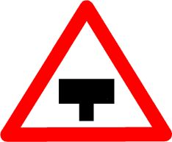 | Major road ahead
 | 69 | This sign indicates | 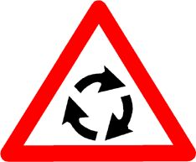 | Round about
 | 70 | This sign indicates | 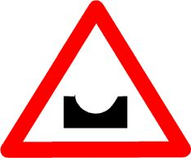 | Dangerous deep
 | 71 | This sign indicates | 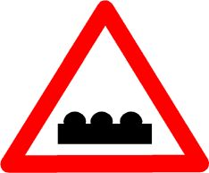 | Speed braker
 | 72 | This sign indicates | 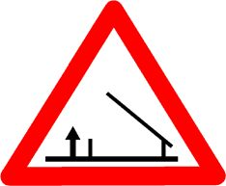 | Barrier ahead
 | 73 | This sign indicates | 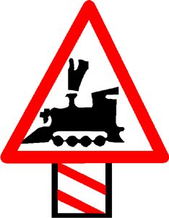 | Unguarded level crossing 200 mts
 | 74 | This sign indicates | 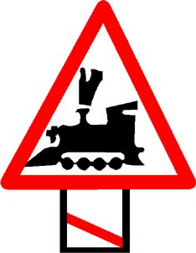 | Unguarded level crossing 50-100 mts
 | 75 | This sign indicates | 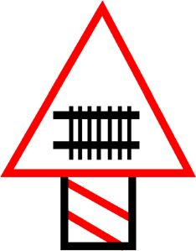 | Guarded level crossing 200 mts
 | 76 | This sign indicates | 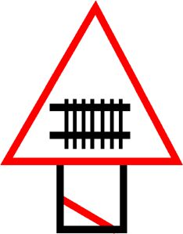 | Guarded level crossing 50-100 mts
 | 88 | This sign indicates | 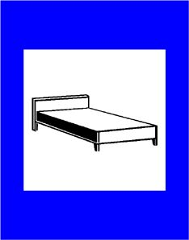 | Resting place
 | 89 | This sign indicates | 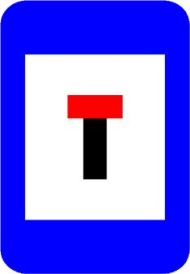 | No through road
 | 91 | This sign indicates | 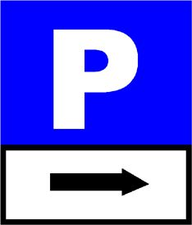 | Park this side
 | 92 | This sign indicates | 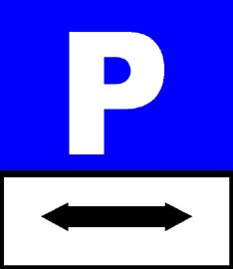 | Parking both sides
 | 93 | This sign indicates | 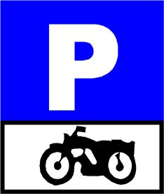 | Scooter && Motorcycle parking
 | 95 | This sign indicates | 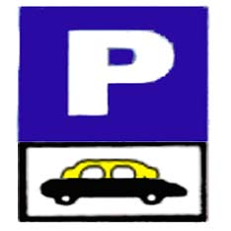 | Taxi parking
 | 96 | This sign indicates | 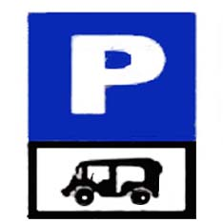 | Auto rickshaw parking

LL Test Question Answer
Sr. No. | Question Description | Answer
1 | While driving you shall always try to drive close to the… | Left-hand side of the road
2 | While turning to the left you shall drive as close as possible to the… | Left-hand of the road
3 | You shall overtake from… | Right of traffic proceeding in same direction
4 | When your vehicle is being overtaken by another vehicle, you should… | Slow down && allow him to pass
5 | Approaching a road junction, corner/pedestrian crossing you shall.. | Slow down and enter
6 | You should give way to all traffic approaching the intersection… | On your right side
7 | When a fire service vehicle/ambulance is approaching, you should | Allow free passage
8 | Driving up nonsignal intersection, people crossing ahead of you, then.. | Stop and allow people to cross the road
9 | You wish to take a U turn at controlled intersection, you should… | Wait until green light glows for U turn
10 | While driving if you wish to change lanes, you should… | Change lanes safely by giving proper signal
11 | When you are about to stop the vehicle, you should… | Raise right arm vertically outside the vehicle
12 | While parking the vehicle you should ensure that it… | Doesn't cause danger/inconvenience to others
13 | While parking your vehicles you should park… | As per signal board or road marking
14 | When road is marked by lanes, you should… | Drive in lane & change with signal
15 | When moving behind another vehicle the driver should… | Keep safe distance from front Vehicle
16 | When you are driving in silent zone… | You should not blow horn
17 | What is the main cause of road accidents ? | Driver
18 | Which vehicle insurance policy is mandatory ? | Third party policy
19 | When should you keep driving licence with you? | Always while driving
20 | Overtaking is very dangerous ……… | On blind turns and crest of hill
21 | The rightmost lane on expressway should be used only ……… | For overtaking purpose only
22 | While slowing down you should apply …… | The brake first and then clutch
23 | Before turning to left you should position your vehicle ……… | In Left lane of road
24 | When your vehicle is being overtaking, you should …… | Slow down and allow him to pass
25 | You are about to stop the vehicle … | Raise right fore arm vertically outside the vehicle
26 | Before turning to right you should position your vehicle …… | In the rightmost lane
27 | The meaning of MSM with respect to negotiating a turn is … | Mirror Signal Manoeuvere
28 | Correct eye sight for holding the driving licence is that applicant … | Should be able to read a car number plate at a distance of 25 mtrs.
29 | The meaning of PSL with respect to turning of vehicle is …… | Position Speed Look
30 | How many driving lecences can one person hold at a time? | One licence only
31 | A driver whose driving licence is suspended or revoked can ……. | Not to drive under any circumstances
32 | If dazzled by headlights of oncoming vehicle you should … | Slow down and stop the vehicle to the left side of road
33 | At zebra crossings you should …. | Stop and allow pedestrians to cross the road
34 | If two vehicles are approaching at an uncontrolled intersection at same time then preference should be given to ……. | One approaching from right

